Network Architecture and Protocol Lab

Booklet 6
Submitted by: Jamil Ahmed
Neptun Code: JZT75Y

4.1

- What modes do we have to configure on each network adapter?
The network adapter modes configured in this lab are Bridged Adapter and NAT. Bridged Adapter is used to connect VMs to the same physical network so they can communicate with each other using manually assigned IP addresses. NAT is used on VM1 to provide access to the Internet by translating private IP addresses into a public one.

- What command the IP addresses can be configured with?
The IP addresses can be configured using the ifconfig command. For example, an interface can be assigned an IP address and subnet mask with:
sudo ifconfig eth0 1.1.123.2 netmask 255.255.255.0 up
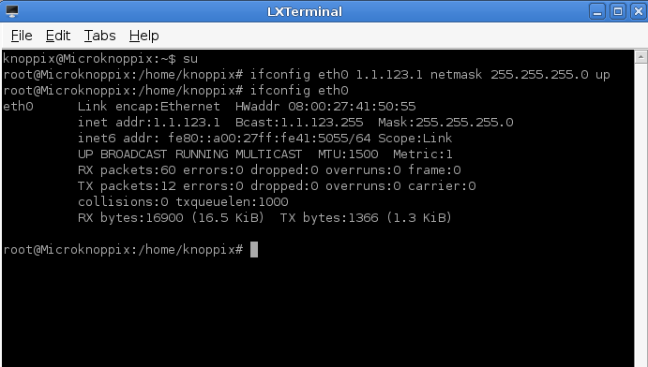

4.2

- What is the meaning of the routing table?
The routing table is a data structure in a system that determines how packets are forwarded to different networks. It contains information about directly connected networks and routes to remote networks, including the gateway through which packets must be sent. When a packet is generated, the system checks the routing table to decide the best path for delivery.

- What command the access of a direct network can be configured with?
Access to a direct network can be configured using a route that specifies the interface (without a gateway), for example:
sudo route add -net 1.1.123.0 netmask 255.255.255.0 eth0

- What command the access of a remote network can be configured with?
Access to a remote network is configured using a gateway (router), for example:
sudo route add -net 1.1.14.0 netmask 255.255.255.0 gw 1.1.123.1
This tells the system to send packets to the specified gateway to reach the remote network.
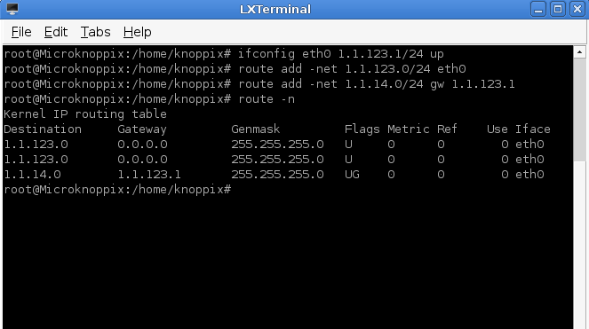

4.3

- How can we find the number of routers between two nodes? Determine the command?
The number of routers between two nodes can be determined using the traceroute command:
traceroute <destination_ip>
Each hop shown in the output represents a router along the path. By counting the hops, we can determine how many routers the packet passed through.

- What does RTT (Round-Trip Time) value prove?
RTT (Round-Trip Time) represents the time taken for a packet to travel from the source to the destination and back. It indicates the delay or latency in the network. A lower RTT means faster communication, on the other hand, a higher RTT suggests delays due to distance, congestion, or network issues.

